|  |  |
| --- | --- |
| **Use Case ID:** | ML01 |
| **Use Case Name:** | Preprocessing the photo and Extract features |
| **Area:** | Server |
| **Actor:** | ML |
| **Description:** | Extract the features from received photo |
| **Preconditions:** | A valid photo |
| **Postconditions:** | ML module has successfully extracted features from received photo |
| **Triggering Event:** | API send a photo |
| **Main Flow:** | 1. Receive the photo from API 2. Preprocess the photo 3. Extract the features from the photo 4. Return the result of the health status of the plant |
| **Alternative Flow:** | -if user upload invalid photo, warning message should appear to the user to reupload the data.  -if the plant not included with our plants, warning message should appear to the user that app couldn’t check the data. |

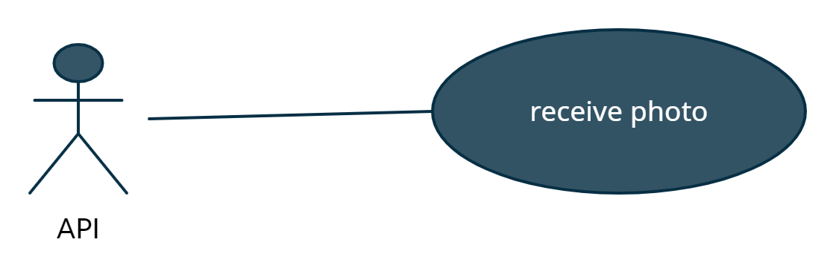

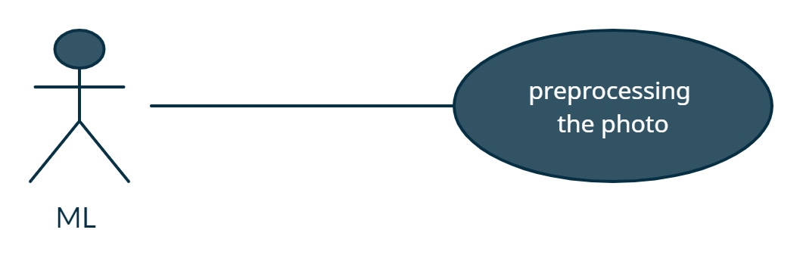

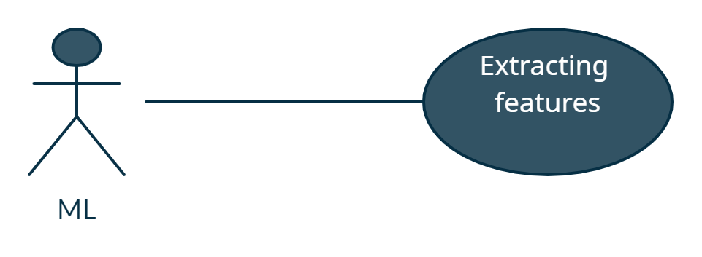

|  |  |
| --- | --- |
| **Use Case ID:** | Fertilizer_Calc01 |
| **Use Case Name:** | Calculate the amount of fertilizer. |
| **Area:** | Server |
| **Actor:** | Fertilizer Calculator |
| **Description:** | Getting the land area and the plant then type return the amount of fertilizer |
| **Preconditions:** | -land area must be existed.  -plant type must be existed. |
| **Postconditions:** | Return the amount of the fertilizer. |
| **Triggering Event:** | API send the land area and plant type to Fertilizer Calculator. |
| **Main Flow:** | 1. Received the land area. 2. Received the plant type. 3. Calculate the fertilizer amount. 4. Return the amount of the fertilizer amount. |
| **Alternative Flow:** | -if the land area not valid number, a warning message should appear to the user. |

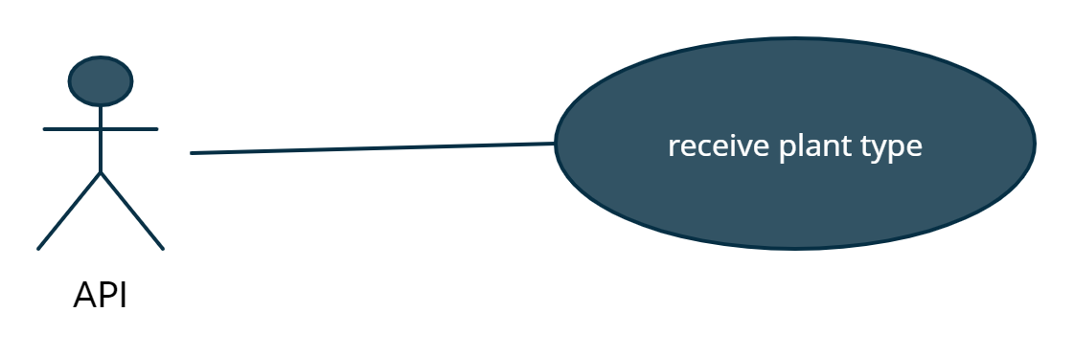

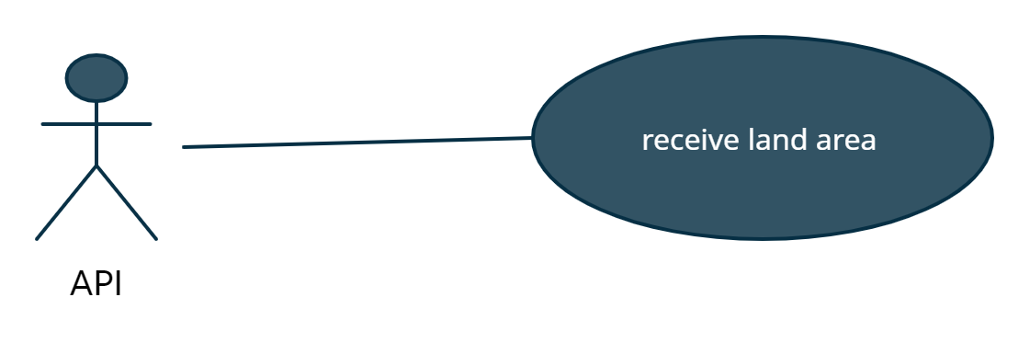

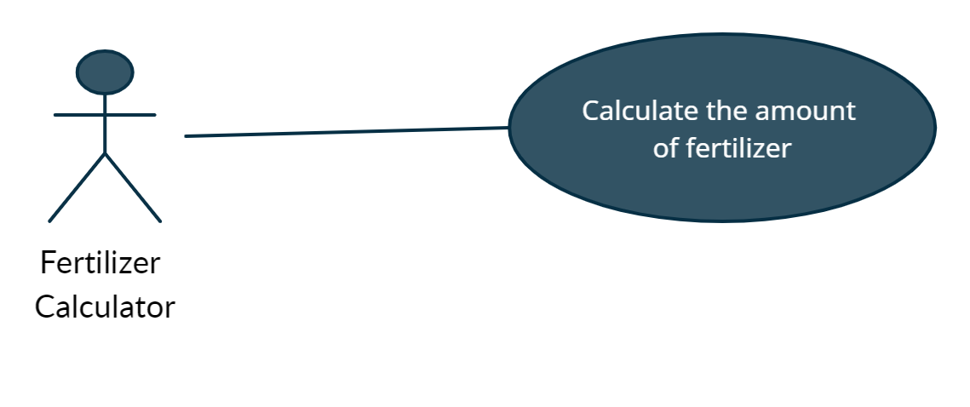

|  |  |
| --- | --- |
| **Use Case ID:** | API01 |
| **Use Case Name:** | Return the result and save posts. |
| **Area:** | Server |
| **Actor:** | API |
| **Description:** | API save user posts and return the result diseases,  Fertilizer quantity. |
| **Preconditions:** | -Photo must be existed.  -land area must be existed.  -plant type must be chosen. |
| **Postconditions:** | API return the result of plant status. |
| **Triggering Event:** | Received a photo and plant type or land area. |
| **Main Flow:** | -user take or upload a plant photo.  -API send a photo to ML module.  -user enter land area and plant type.  -API send land area to Fertilizer Calculator. |
| **Alternative Flow:** | - -if the land area not valid number, a warning message should appear to the user.  -if user upload invalid photo, warning message should appear to the user to reupload the data. |

